

`

TOM Integration

Interface Specification
Shipment notification (Bill of lading) to Storeline
[J097.5]

Project BEN Code: | TBC
Author: | Chris Rippingale
Date: | 20/02/2007
Version: | 0.1
Status: | Draft
Modified By:
Reviewed By:

Change Record

Author | Date | Version | Change Reference, description
Chris Rippingale | 20/02/2007 | 0.1 | First Draft

Reviewers

Name | Date | Version | Position

At least one reviewer is required.

Sign-Off

By signing this form, I understand and agree with the contents of this document.

Business Owner/Customer | <Business Owner/Customer>
Position | <Relationship to the Programme> e.g. Stakeholder
Signature | <Physical signature or via email approval>
Date | dd/mm/yyyy (<version signed off>)

Distribution List

Name | Date of Issue | Version
 | <Issue Date> | <Version No>

Document Source
Clear Case

Related Documents

A complete interface specification requires three documents- an Interface Specification, an Information Architecture Context diagram, and a Mapping spreadsheet. This section identifies these documents:

Information Architecture Context diagram
TBC

Mapping spreadsheet
J097.5 – BOL OL to GFO Mappings v1.xls
Table of Contents
1 Introduction 6
1.1 Purpose of Document 6
1.2 Background 6
1.3 Scope 6
2 Description and Requirements for the End-to-End Interface 7
2.1 Description of the End-to-End Interface 7
2.2 Architecture 7
2.3 Requirements for the End-to-End Interface 7
3 Processing required in an Extract-Stage of the interface 9
3.1 Scope 9
3.2 Source Message Schema 9
3.3 Message Transport Details 9
3.4 Naming and Configuration 10
3.5 Environment and Security Context 10
4 Processing required in the Messaging Stage of the interface 11
4.1 Scope 11
4.2 Data Validation 11
4.3 Filtering 11
4.4 Mapping 11
4.5 Target Message Schema 11
4.6 Message Format 12
4.7 Message Transport Details 13
4.8 Naming and Configuration 14
4.9 Environment and Security Context 14
4.10 Non-Functional Requirements 3
5 Processing required in the RMS import stage of the interface 3
5.1 Scope 3
5.2 Data Validation 3
5.3 Filtering 3
5.4 Mapping 3
5.5 Target Message Schema 3
5.6 Message Transport Details 3
5.7 Environment and Security Context 15
6 Testing Deliverables 17
7 Deployment 18
8 Assumptions and Outstanding Issues 19
8.1 Assumptions 19
8.2 Outstanding Issues 19
Appendix A Volumes 20
Appendix B Glossary 21
Appendix C Document Control 22

Introduction

Purpose of Document
The purpose of this document is to describe the requirements for the interface of an ASN containing a Bill of Lading (BOL) into the Integration Layer (IL), enriched with Purchase Order Details (POD) and sent to Group Forecast and Order system (GFO).

The document is of a sufficiently technical nature to allow a developer to build an actual interface. Additionally the document contains detail that might sit logically within a Technical System Design (TSD) document, but is contained here for expediency. There is therefore no associated TSD for this interface.

This interface is the same for both the Turkey and US implementations.

Background
As part of the ordering process GFO requires order details of each delivery sent out to store. This interface contains details of the process of alerting GFO of the ANS.

ORWMS is the source of the ASN which contains the BOL and Allocation Number. The ASN is published into the integration layer (via RIB messages in Oracle Retail v12, via files in Oracle Retail v10), and is enriched from the IDS. This interface is concerned with translating data from ASN and IDS to GFO.

Scope
The Interface Specification covers:

- audit requirements across the interface
- security requirements across the interface
- timing/frequency requirements or constraints
- support requirements
- archiving
- the data format to be used for the interface at each stage (e.g. xml messages)
- the normal processing required at each stage
- recovery from failure required at each stage
- volumes.

Note that it is Tesco strategy to avoid placing any business logic in integration layer processing.

Description and Requirements for the End-to-End Interface

Description of the End-to-End Interface
The interface is a transform of an ASN, enriched with PO details from IDS and upload into the GFO system via integration layer. The interface will run when an ASN is received and passed in via sequencing component and consists of a BizTalk Orchestration and supporting assembles that extract data from the IDS and format the output target load left off flat file for GFO.

TBC: FULL DESCRIPTIOIN OF WHAT HAPPENS NEEDED HERE?

The interface will make use of the audit and traceability components that are being developed as part of the Operational Framework stream. These components will be pluggable, and will be useable from BizTalk. TBC At the time of writing (2007-02-20) the components are in design. Although not ready for use, they are included on the Information Architecture Context diagram where their functionality is required. Developers should put a ‘placeholder’ in their code / configurations as appropriate.

Architecture
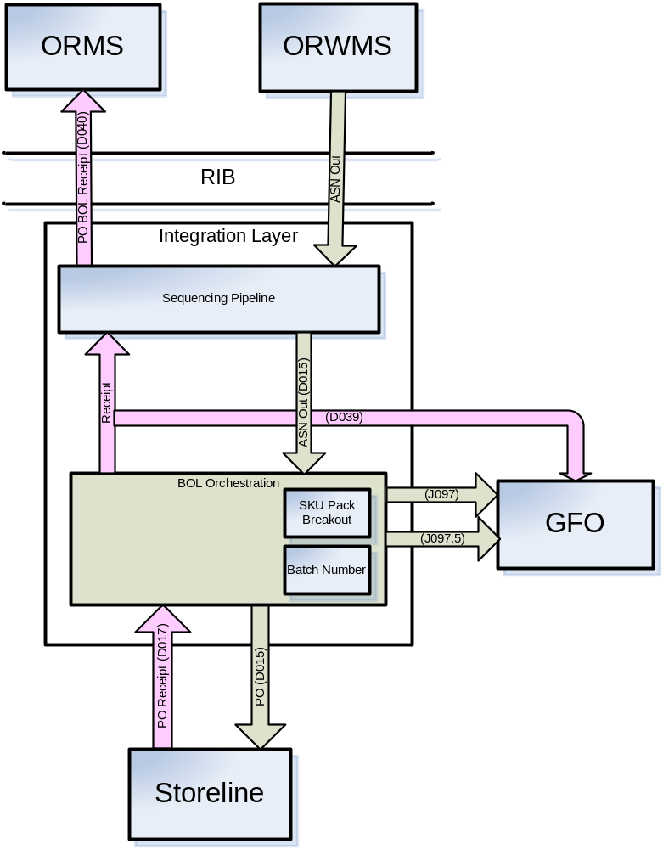

Requirements for the End-to-End Interface

Audit Requirements | The interface will use the components provided by the Operational Framework to satisfy audit requirements.
Security Requirements | The interface executes within a secure private domain. There are no additional security considerations required.
Timing/Cut-off Constraints | TBC.
Performance Requirements | Once received the ASN, the interface should be capable of extracting data from the IDS and delivering the resulting to GFO before the identified cut-off time. To be finalised –This must take into account the cut-off point after which any updates from OWRMS will not be interfaced to GFO..
Reliability and Availability Requirements | The interface-run should be atomic in nature. Where it is not possible to implement an atomic nature of interface, appropriate mechanisms should be in place to raise/alert appropriate parties.
Scalability Requirements | N/A - No scalability issues exist. There will only ever be a single instance of the IDS and GFO in a TOM implementation and therefore no requirement for multiple files to multiple locations.
Operational Support Requirements | No such requirement has been agreed upon at the time of writing this document. However, it is perceived that there would be interface support requirements after go-live date that would require an evaluation.
Likelihood of Change Requirements | There is no such requirement
Cultural/Global Consideration Requirements | Where the interface is implemented into a country in which a multi-byte character set is required to support the national language, the interface and all participating applications must support a multi-byte character set.
Legal Requirements | N/A
Compliance To Standards Requirements | No compliance exceptions.

Processing Required from ORWMS

Scope
The message will be produced by the Oracle Retail Warehouse Management System and published on the RIB using Java Messaging Service (JMS). The RIB message type will specify the operation performed.

The message generated is published to the Retail Integration Bus (RIB) which can have multiple subscribers; one of these subscribers will be this interface.

Source Message Schema
The message is uniquely identified by the ASN Number (equivalent of BOL No). The message format is XML and the schema is located in TBC

Message Transport Details
Feature | Specification | Additional Information
Source System Name | ORWMS
Source Platform / OS | Oracle Retail
Source Physical Location | TBC
Source Underlying Data Storage Technology | Oracle
Target System Name | Integration Data Store
Target Platform / OS | BizTalk
Target Physical Location | TBC
Target Underlying Data Storage Technology | SQL Server
Transfer Function  Indicate which method will be used to transfer data to the next stage. | HTTP (Put/Post) ◻  HTTPS (Put/Post) □  Message Queue □  FTP □  File Drop (Windows) □  (XCOM) □  JMS ☑
Data Format  Indicate the physical format of the message encapsulating the data. | XML ☑  Delimited □  Positional □
Decryption/Encryption  Is the data encrypted? If so, does it need to be decrypted? | TBC
Decompression/Compression  Is the data compressed? If so does it need to be decompressed? | TBC
Transmission Mode  Synchronous transfers will receive confirmation of completion of the message delivery to final destination. Asynchronous transfers receive confirmation of message reception by the integration layer. Bulk transfers do not have a return message path. | Synchronous □  Asynchronous ☑  Bulk Data □
Real-time/Scheduled Batch  Is the data sent one change at a time, as the change occurs using real-time messaging? Or are changes communicated on a time schedule using a batch method  Provide scheduling details eg. Time, CA7 dependencies,etc. | TBC
Archiving  Is there a requirement to store the being transformed? Incoming or outgoing data? All data or a specific subset? For how long should the data be stored? | TBC – handled by framework if necessary
Logging  Should logs be kept of all actions? For how long should these be stored? | TBC – handled by framework if necessary
Error Handling  Specify what processing is required if an error occurs while transferring the data. Is retry required? How many times, with what interval? Is alerting required? Specify handling of duplicate messages. | TBC – handled by framework if necessary

Naming and Configuration

This section should contain details of naming and configuration for BizTalk ports, RTI instructions, SSIS packages.

TBC

Environment and Security Context
This section should contain any additional environment specific details deemed necessary. The information will depend on the technologies used by the interface. For example employing BizTalk this section would include details of the host – In-Process Host, Isolated Host, and whether the host was Trusted/Untrusted. For interfaces employing the RTI indicate whether the instruction is Hosted/Unhosted.

Also indicate the account that the process will run under. In projects where the target deployment environment does not exist at the time of writing the interface specification, the information should be added at a later date (but obviously, prior to deployment).

Account details will be included here once we have visibility of the environments.

Non-Functional Requirements
This section should contain any non-functional requirements pertaining to this stage of the interface.

Processing Required in the Integration Layer

Scope
Shipping Agent monitors the file in the configured location for every new file and submits the same to the remote UNIX –AIX share via FTP.

When the ASN with BOL details is received by the integration layer, these details will be mapped to a common form and stored in the integration data store.

TBC: How does GFO want to react to 354 Deletes?

The ANS message contains items at pack level. A previous interface (D015) will break these packs into item level. Next the ASN is enriched with the POD from a local API. The POD comes from the IDS. This data is added to the ASN message.

Data Validation
Data Validation will be done by the target GFO system.

Filtering
There is no filtering requirement.

Mapping
RIB ASN -> Common ASN -> LoadLeftOff.
The target flat file is called Load Left Off and specified in 4.5 Target Message Schema

Please refer the mapping spreadsheet at <location> for mapping.

Target Message Schema
Field Name | Type | Start | Length | COBOL Format
Header Record
JLLDA-LOAD-LEFT-HDR
03 JLLDA-REC-TYPE | Char |  | 1 | X
03 JLLDA-LOAD-REF | String |  | 12 | X(12)
03 JLLDA-RETAIL-OUTLET-NO | Int |  | 5 | 9(5)
03 JLLDA-DEL-STK-CTR-NO | Int |  | 5 | 9(5)
03 JLLDA-RECEIPT-NOTE-NO | String |  | 6 | X(6)
03 JLLDA-LOAD-CLOSED-DATE | Int |  | 8 | 9(8)
03 JLLDA-LOAD-CLOSED-TIME | Int |  | 6 | 9(6)
03 JLLDA-EST-DEL-DATE | Int |  | 8 | 9(8)
03 JLLDA-EST-DEL-TIME | Int |  | 6 | 9(6)
03 FILLER | String |  | 23 | X(23)
Detail Record
JLLDB-LOAD-LEFT-REC
03 JLLDB-REC-TYPE | Char |  | 1 | X
03 JLLDB-BASE-PRODUCT-NO | Int |  | 9 | 9(9)
03 JLLDB-UOD-NO | Int |  | 6 | 9(6)
03 JLLDB-RMS-ORD-NO | Int |  | 10 | 9(10)
03 JLLDB-PBL-IND | Char |  | 1 | X(1)
03 JLLDB-REQ-DEL-DT | Int |  | 8 | 9(8)
03 JLLDB-ORD-TYPE | Char |  | 1 | X
03 JLLDA-STK-CTR-NO | Int |  | 5 | 9(5)
03 JLLDB-TRD-UNT-DELY-QTY |  |  | 7 | 9(5)V99
03 JLLDB-UNIT-SIZE |  |  | 7 | 9(5)V99
03 JLLDB-TU-NOTIONAL-WT |  |  | 7 | 9(5)V99
03 JLLDB-TRADTPN | Int |  | 9 | 9(9)
03 JLLDB-CODE-LIFE-DATE | Int |  | 8 | 9(8)
03 FILLER | Char |  | 13 | X(13)

Message Format
An example of the expected message format

Message Transport Details

TBC
For messages destined for TOM system, the following applies

Feature | Specification | Additional Information
Source System Name | RTI
Source Platform / OS | WOF
Source Physical Location
Source Underlying Data Storage Technology | File System
Target System Name | CR
Target Platform / OS | UNIX –AIX 5.3
Target Physical Location
Target Underlying Data Storage Technology
Transfer Function | HTTP (Put/Post □  HTTPS (Put/Post) □  Message Queue □  FTP ☑  File Drop (Windows) □  (XCOM) □
Data Format | XML □  Delimited □  Positional ☑
Decryption/Encryption | No
Decompression/Compression | No
Transmission Mode | Synchronous □  Asynchronous ☑  Bulk Data □
Real-time/Scheduled Batch | Real-time
Archiving | There is no archiving requirement
Logging  Should logs be kept of all actions? For how long should these be stored? | Logging should occur, such that the message can be recreated if necessary.
Error Handling | If the message cannot be delivered, retry 6 times at 10 minute intervals, then raise alert.  Processing should prevent sending of duplicate messages, unless this occurs during recovery from failure.

Naming and Configuration
TBC
This section should contain details of naming and configuration for BizTalk ports, RTI instructions, SSIS packages.

RTI
Instruction Name: Tesco_TinaB_GFO_File_Delivery
Instruction Details
Description | To be determined
Enabled | True
Type | Hosted
Operational Window
Schedule | N/A
Enabled | False
Host Details
Account | To be determined
Operational Details
Worker Threads
Priority
Batch Size
Period
Retry Attempts
Timeout
Require Data Send
Exception Management
Treat Fatal Adapter Exception As
Treat Unhandled Exceptions As

Environment and Security Context
This section should contain any additional environment specific details deemed necessary. The information will depend on the technologies used by the interface. For example, if employing BizTalk, this section would include details of the host – In-Process Host, Isolated Host, and whether the host was Trusted/Untrusted. For interfaces employing the RTI indicate whether the instruction is Hosted/Unhosted.

Also indicate the account that the process will run under. In projects where the target deployment environment does not exist at the time of writing the interface specification, the information should be added at a later date (but obviously, prior to deployment).

Account details will be included here once we have visibility of the environments.

Non-Functional Requirements
This section should contain any non-functional requirements pertaining to this stage of the interface.

On successful delivery of the file to the target system, the audit log should be updated via the Operational Framework pipeline component or adapter (to be determined).

In the event of a failure the file should be written to the failed files location, and an alert should be raised.

Processing required in the RMS import stage of the interface

Scope
Not Required

Data Validation
Not Required

Filtering
Not Required

Mapping
Not Required

Target Message Schema
Not Required

Message Transport Details
Not Required

Naming and Configuration
This section should contain details of naming and configuration for BizTalk ports, RTI instructions, SSIS packages.

Environment and Security Context
Not Required

Non-Functional Requirements

Testing Deliverables
Unit Test Scripts and test cases are kept at the following location <location>

Deployment

Assumptions and Outstanding Issues

Assumptions
ID | Assumption
1 | BOL number is unique
2 | If a Denver or Load Left Off fails, the orchestration fails.

Outstanding Issues
ID | Issue | To be addressed by

- Volumes
- Glossary

Acronym | Term | Description
ASN | Advanced Shipment Notice | When a lorry leaves DC
Load Left Off | Expected GFO file | Notification of lorry leaving and products not on lorry
SKU | Stock Keeping Unit
EAI | Enterprise Application Integration | The process of meeting the data requirements of applications by providing a message based transport from disparate data sources across all forms of enterprise technology.

- Document Control
Change Record

Author | Date | Version | Change Reference, description
Chris Rippingale | 20-02-2007 | V0.1 Draft | First issue

Related Documents

Author | Date | Version | Title

Distribution

Name | Position | Approver/Contributor/Other
Nathan Smith | Enterprise Architect
Adrian Hinks | Engagement Architect
David Onyett | Project Lead

